**Pizza Sales SQL Queries**

**1.Total Revenue**

select sum(total_price) as Toal_Sales from pizza_sales

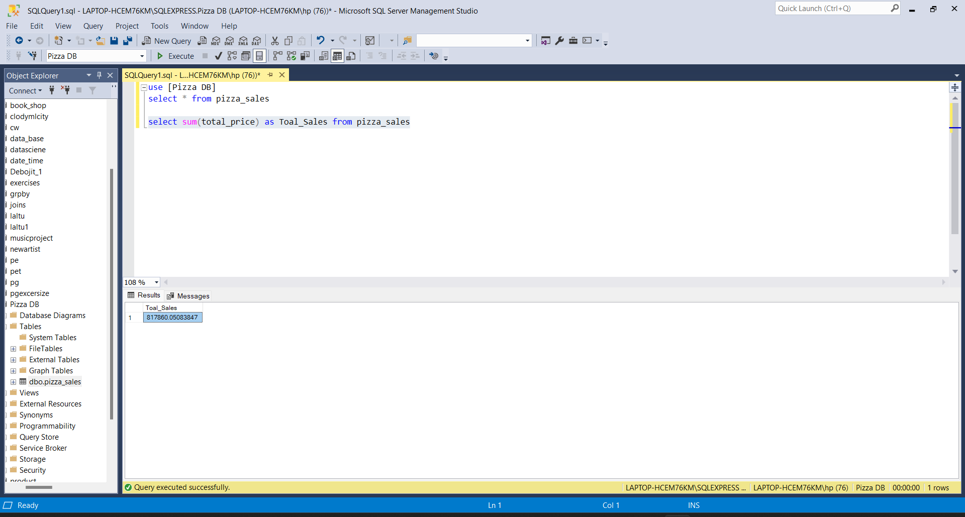

`

**2. Average Oder Value**

select sum(total_price)/count(distinct(order_id)) as Avg_Order_Value from pizza_sales

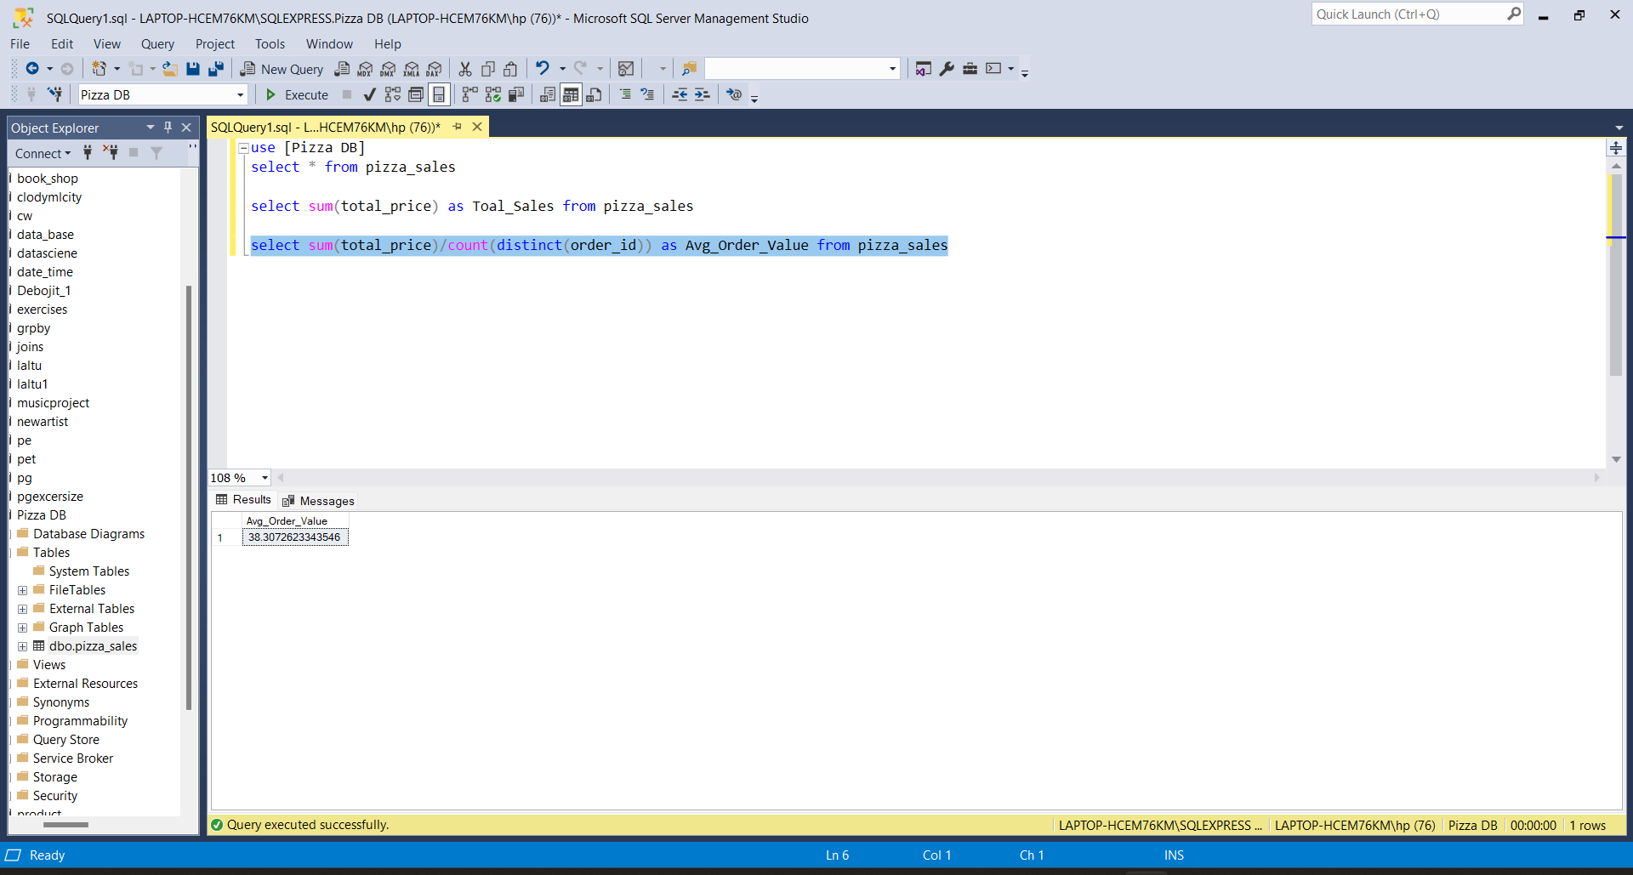

**3. Total Pizza Sold**

select sum(quantity) as total_pizza_sold from pizza_sales

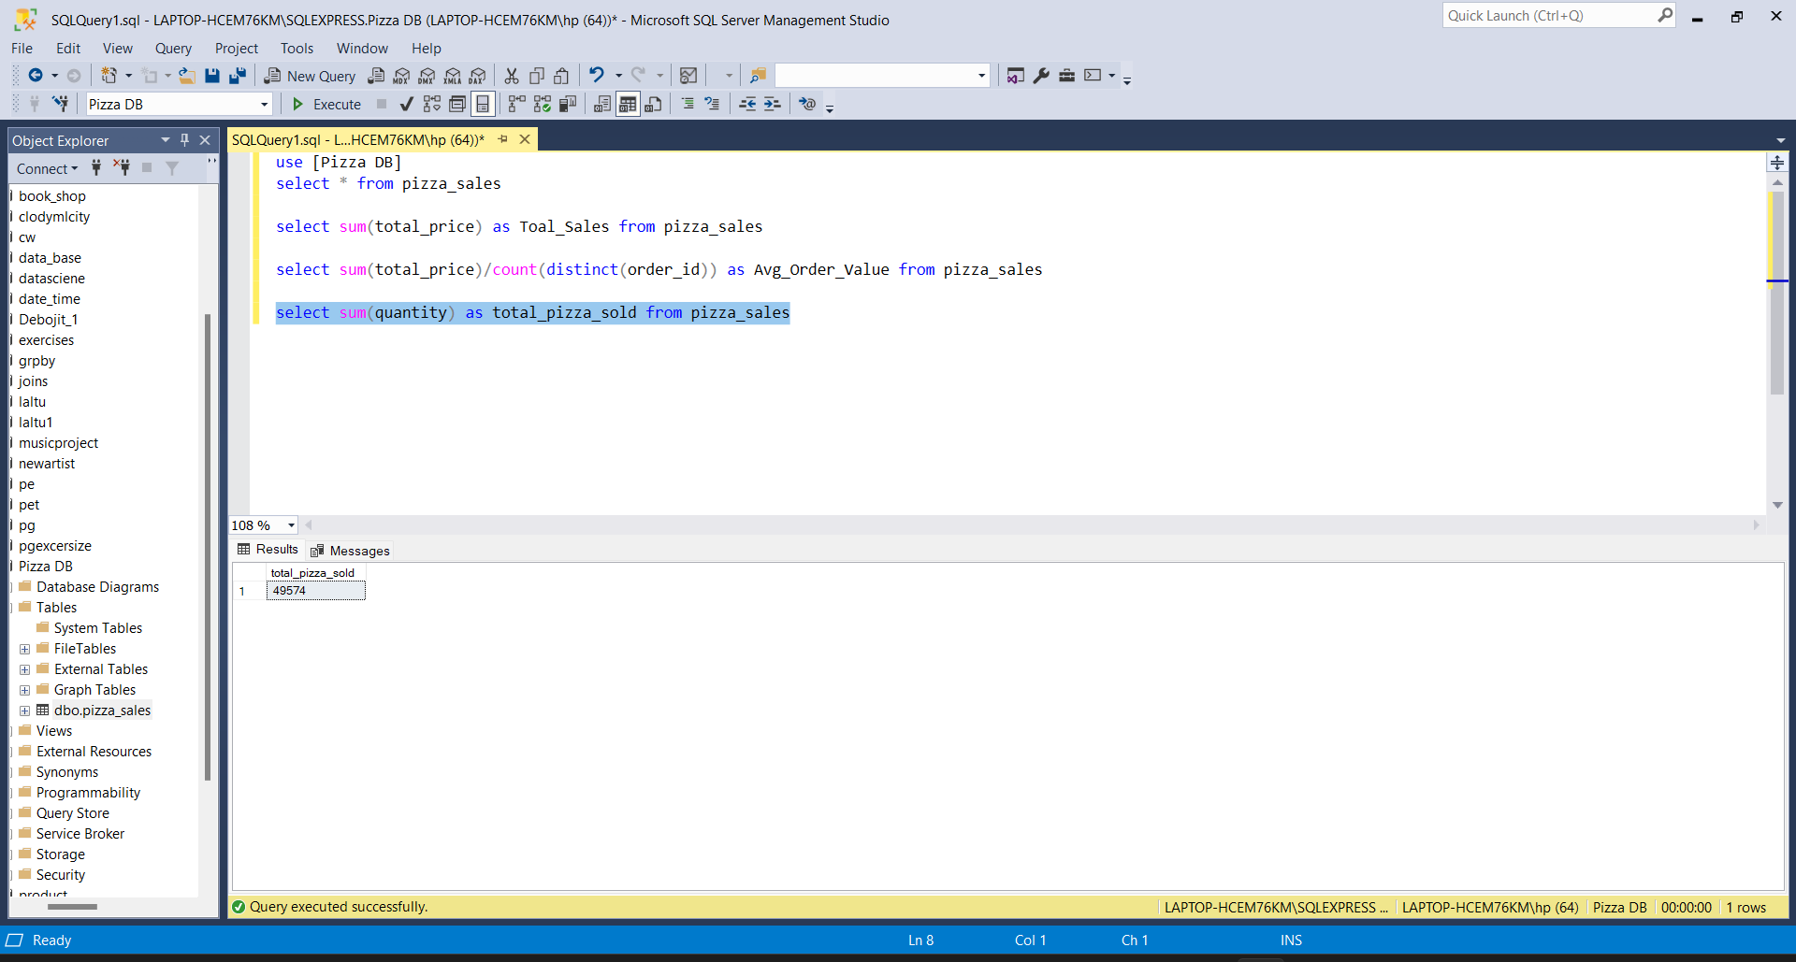

**4. Total Orders**

select count(distinct(order_id)) from pizza_sales

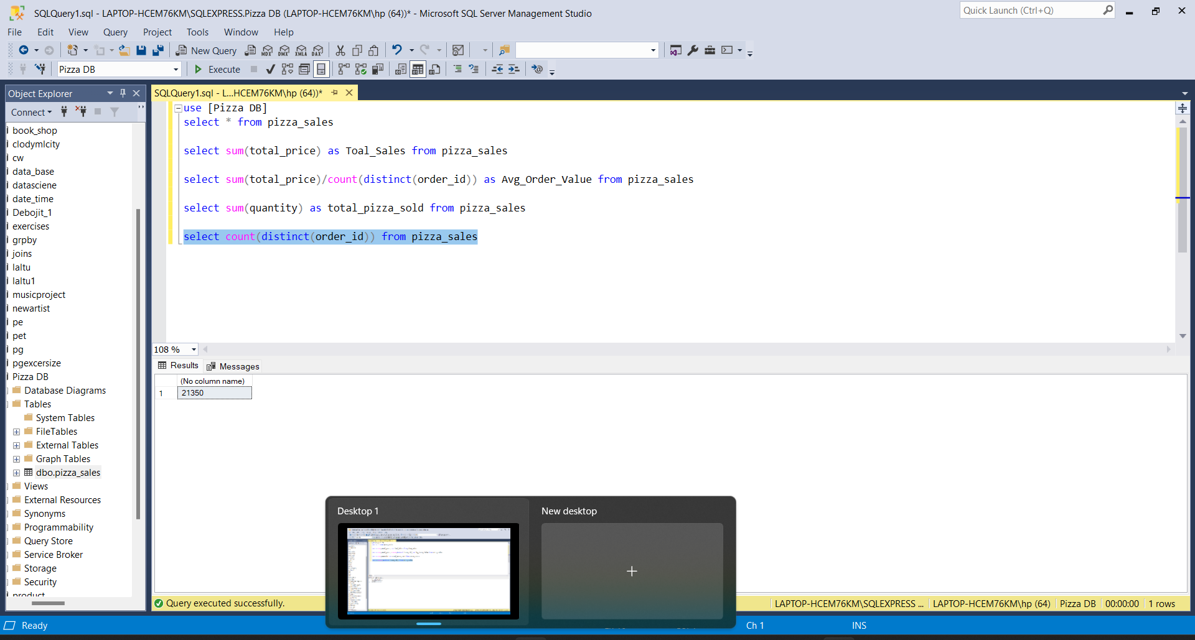

**4. Average Pizza Per Order**

select cast(cast(sum(quantity) as decimal (10,2))/cast(count(distinct(order_id)) as decimal (10,2)) as decimal (10,2)) as avg_pizza_sold_per_order from pizza_sales

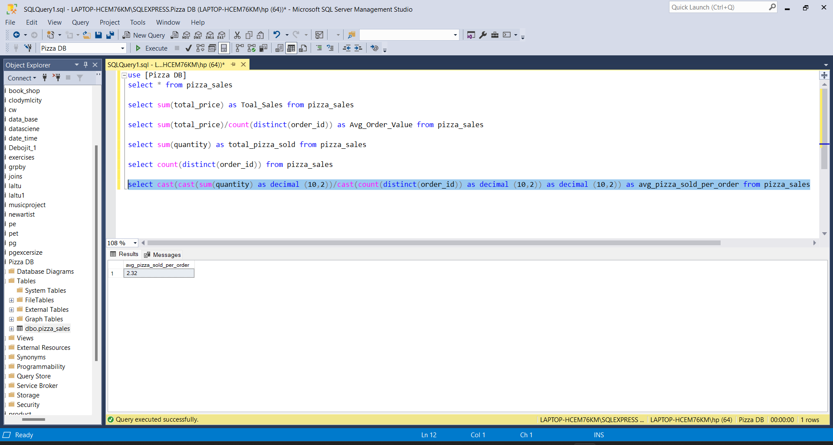

**Charts Requirements**

**1.Daily Trend for total orders:**

Create a bar chart that displays the daily trend of total orders over a specific limit period. This chart will help us identify any patterns or fluctuations in order volumes on a daily basis.

select datename(DW,order_date) as order_day, count(distinct(order_id)) as

total_orders from pizza_sales group by datename(DW,order_date)

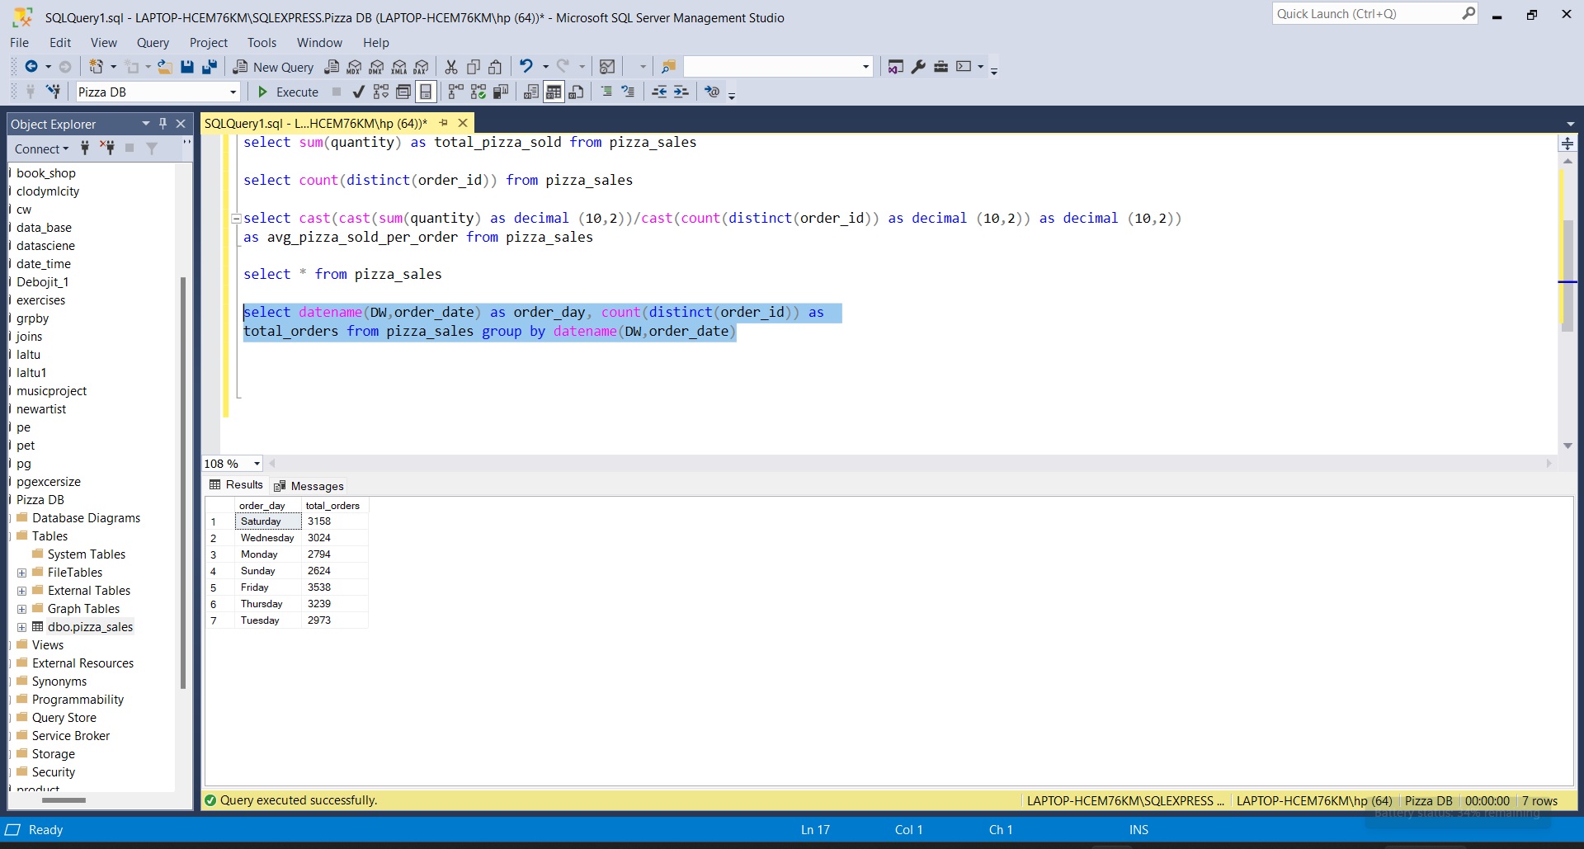

**2.Monthly and Hourly Trend for total orders**

Create a line line chart that illustrates the hourly trend of total orders throughout the day. This chart will allow us to identify peak hours or periods of high order activity.

select datename(Month,order_date) as Month_Name, count(distinct(order_id)) as total_orders

from pizza_sales group by datename(Month,order_date) order by total_orders desc

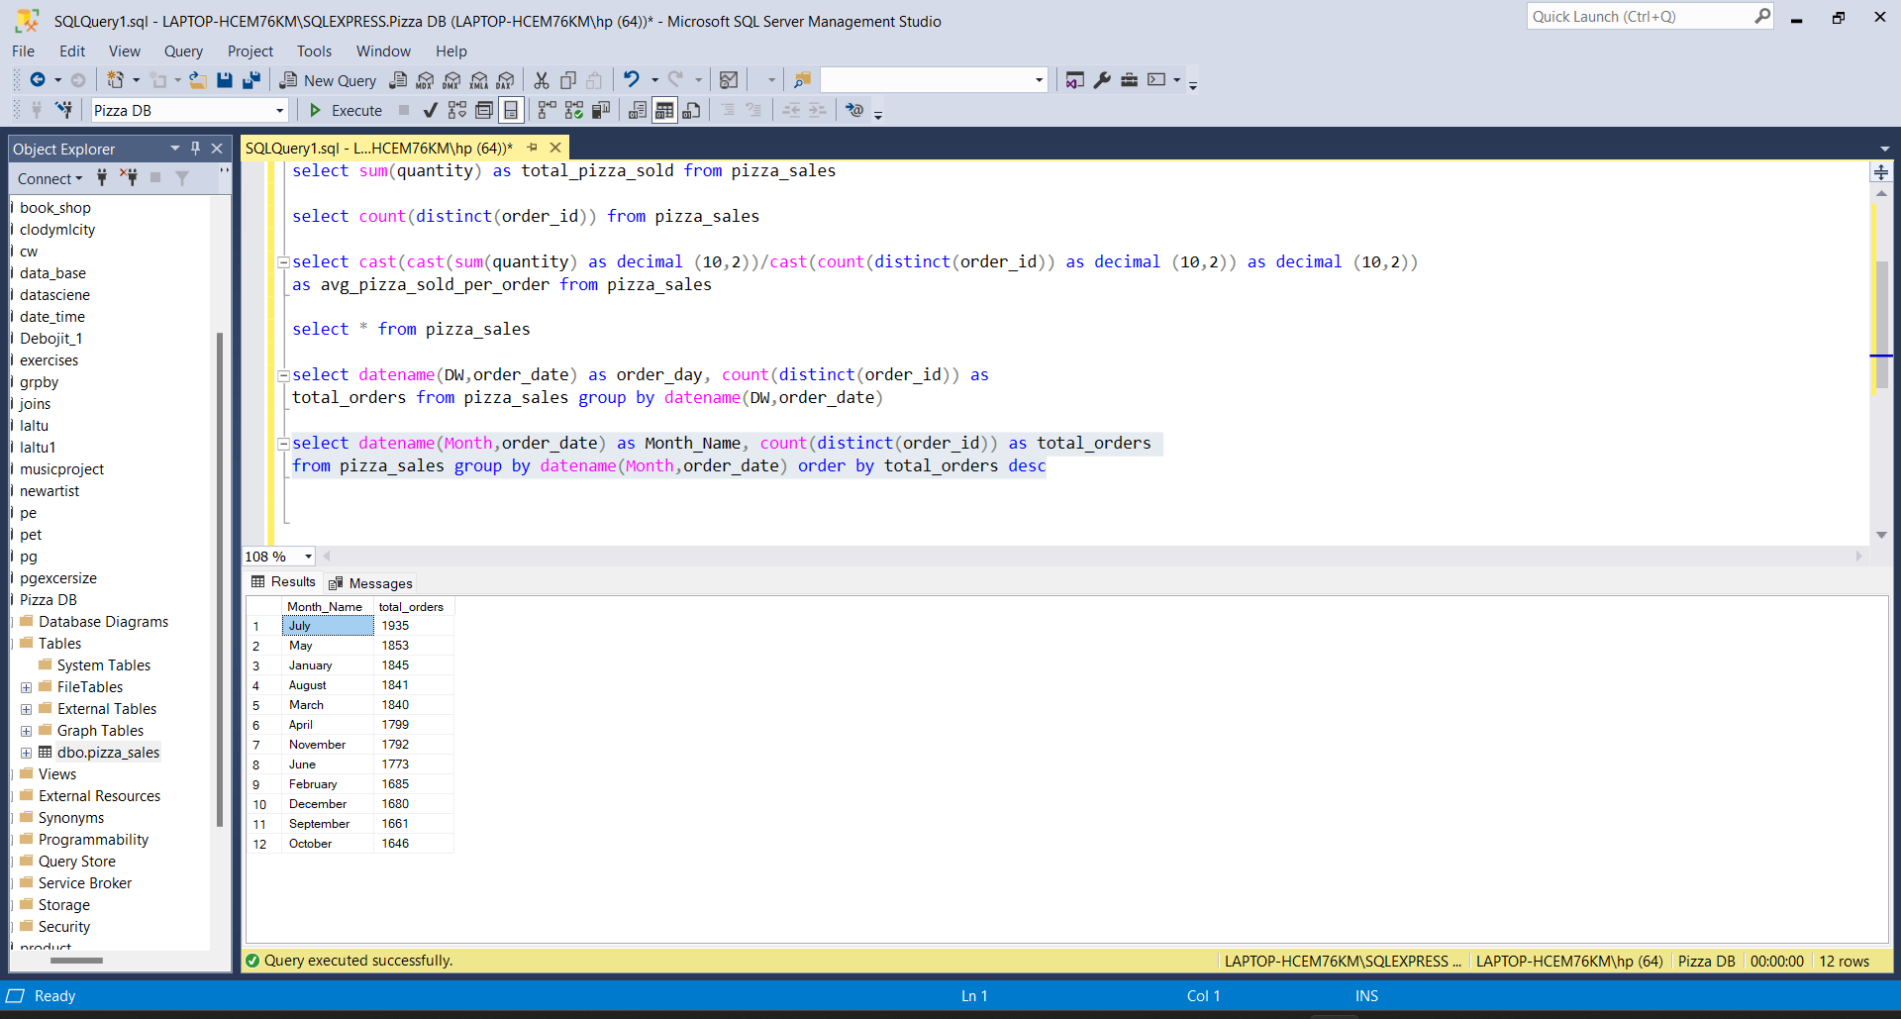

select datename(HOUR,Order_time) as Hour_Time, count(distinct(order_id)) as total_orders

from pizza_sales group by datename(HOUR,Order_time) order by total_orders desc

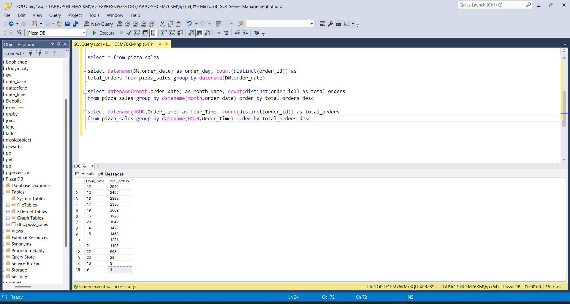

**3. Percentage of sales by pizza category**

Create a pie chart that shows the distribution of sales across different pizza categories. This chart will provide insights into the popularity of various pizza categories and their contribution to overall sales.

select round(sum(total_price),2) as total_sales, pizza_category as category, round(sum(total_price)*100/(select sum(total_price) from pizza_sales),2) as "PCT(%)"

from pizza_sales group by pizza_category

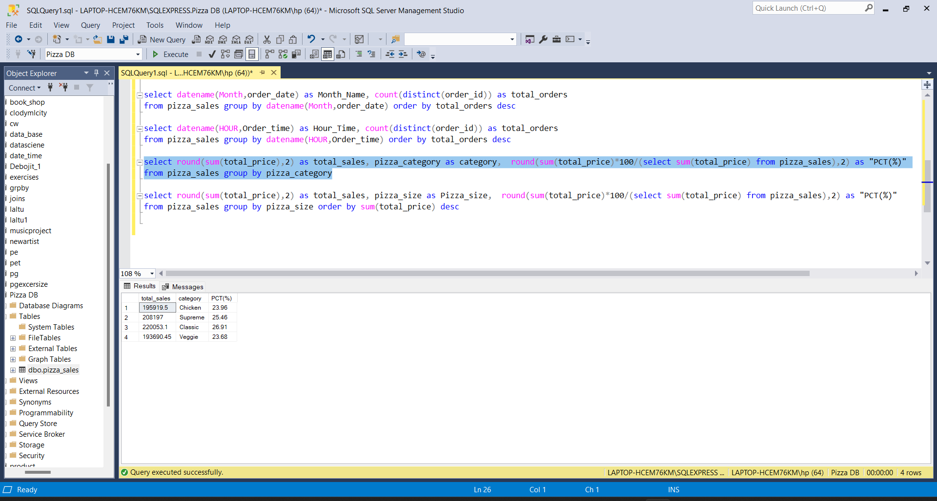

**4. Percentage of sales by pizza Size**

Create a pie chart that shows the distribution of sales across different pizza Size. This chart will provide insights into the popularity of various pizza Sizes and their contribution to overall sales.

select round(sum(total_price),2) as total_sales, pizza_size as Pizza_size, round(sum(total_price)*100/(select sum(total_price) from pizza_sales),2) as "PCT(%)"

from pizza_sales group by pizza_size order by sum(total_price) desc

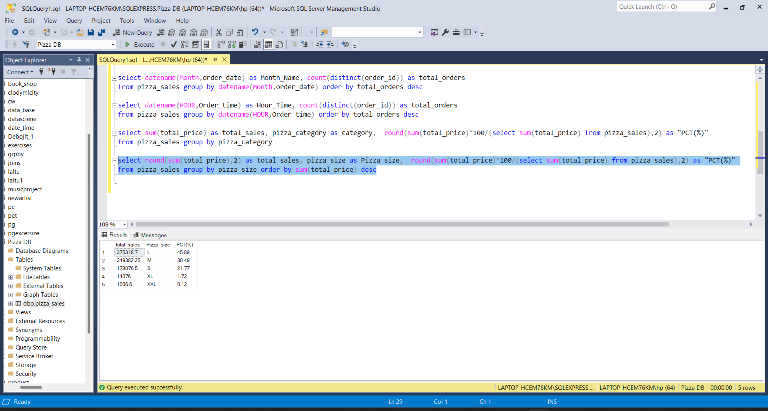

**5. Total Pizza sold by Pizza Category**

Create a funnel chart that presents the total number of pizzas sold for each pizza category. This chart will allow us to compare the sales performance of different pizza categories.

**6.Top 5 Best Seller by Revenue, Total quanity and total orders**

Create a Bar chart highlighting the top 5 best selling pizzas based on the revenue, total quantity and total orders. This chart will help us to indentify the most popular pizza options.

select top 5 pizza_name, round(sum(total_price),2) as total_sales from pizza_sales

group by pizza_name order by sum(total_price) desc

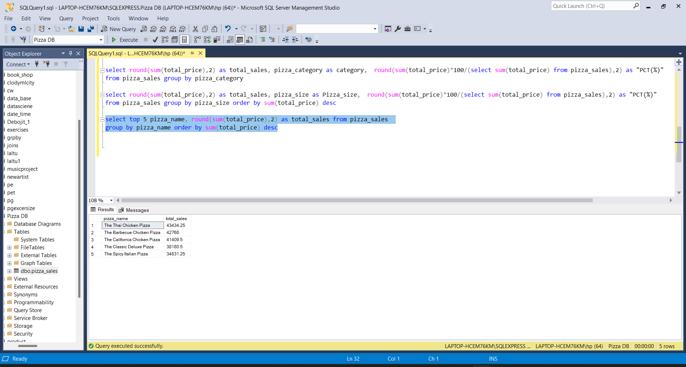

select top 5 pizza_name, round(sum(quantity),2) as total_quantity from pizza_sales

group by pizza_name order by sum(quantity) desc

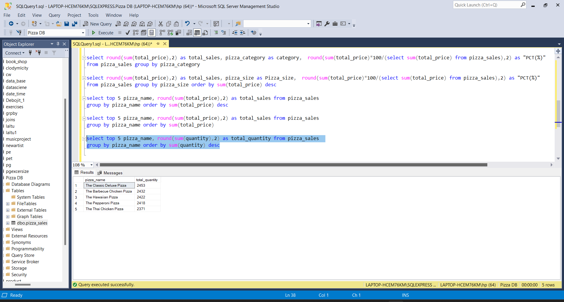

select top 5 pizza_name, round(count(distinct(order_id)),2) as total_orders from pizza_sales

group by pizza_name order by total_orders desc

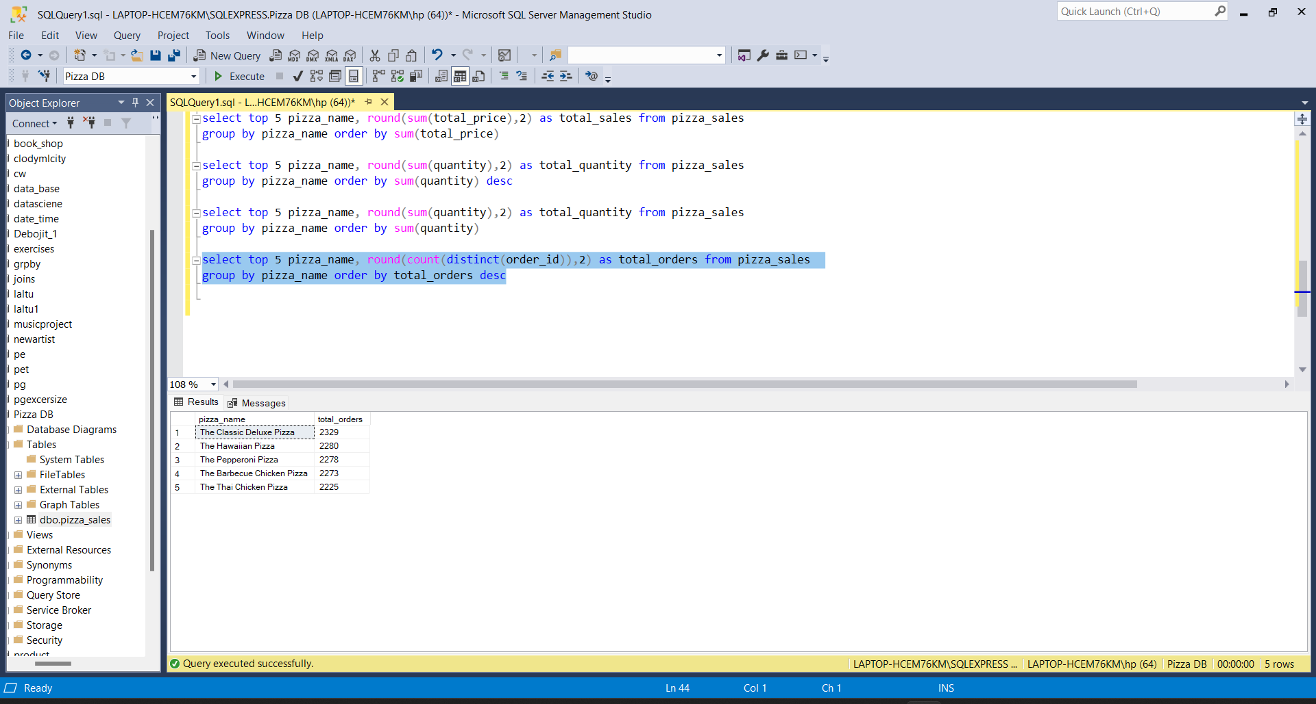

**7.Bottom 5 Best Sellers by Revenue, Total Quantity and Total Orders**

Create a bar chart showcasing the bottom 5 worst-selling pizzas based on the revenue, total quantity, total orders.

select top 5 pizza_name, round(sum(total_price),2) as total_sales from pizza_sales

group by pizza_name order by sum(total_price)

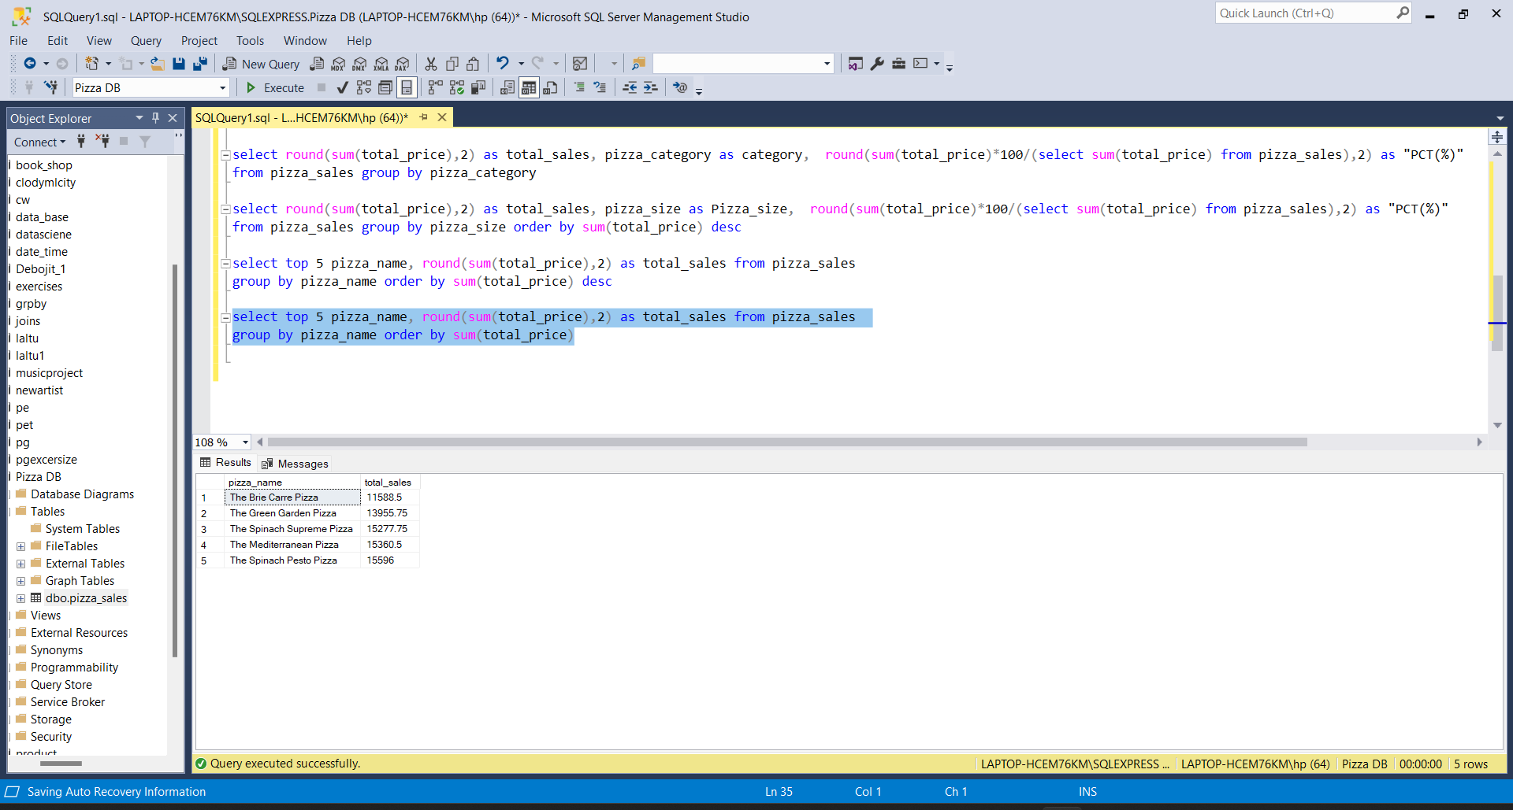

select top 5 pizza_name, round(sum(quantity),2) as total_quantity from pizza_sales

group by pizza_name order by sum(quantity)

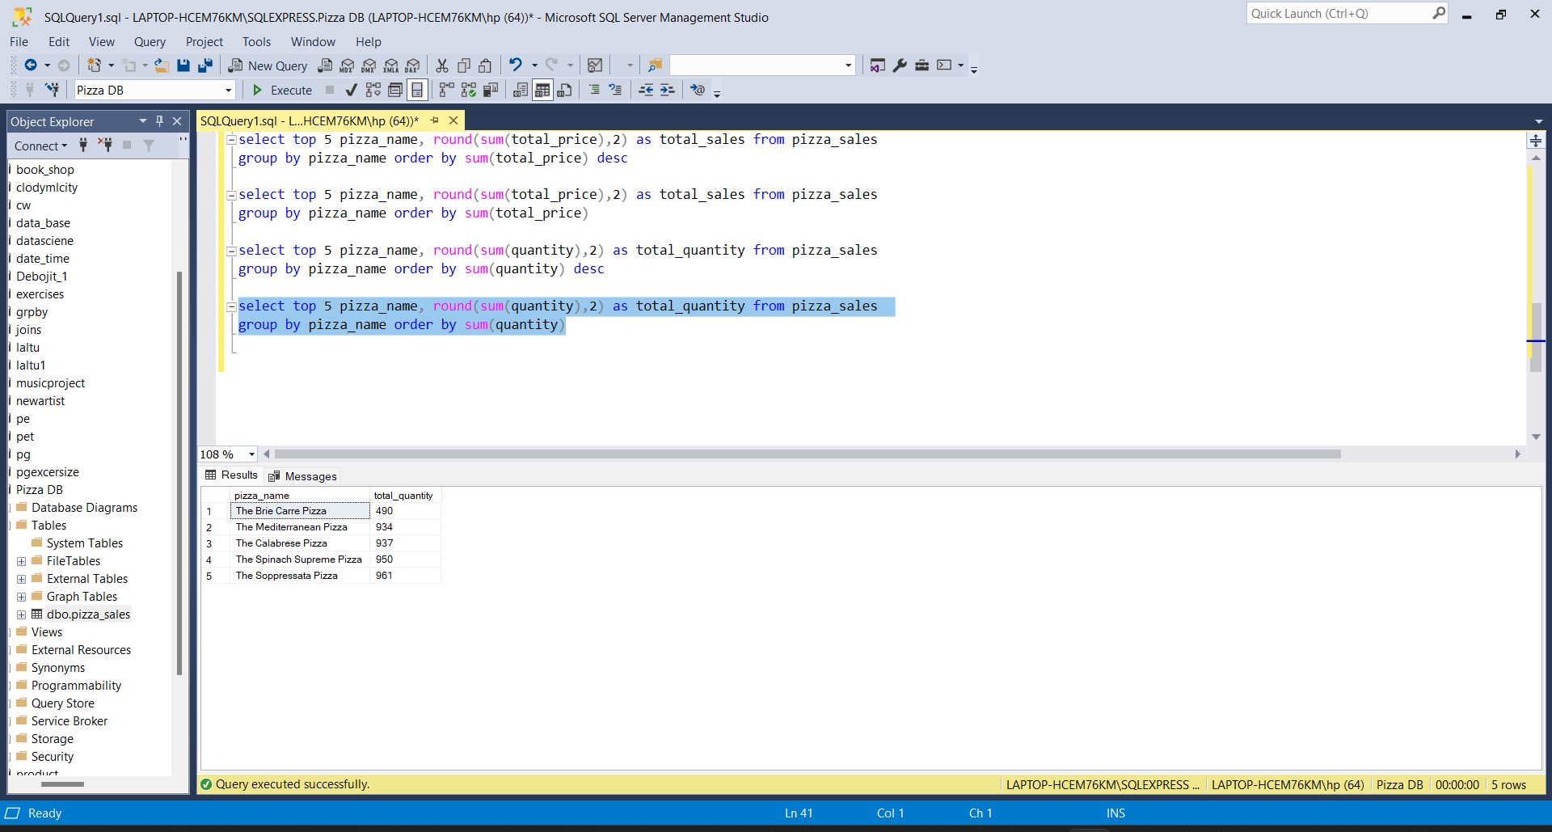

select top 5 pizza_name, round(count(distinct(order_id)),2) as total_orders from pizza_sales

group by pizza_name order by total_orders

